**DevOps Assignment**

**Github url:** https://github.com/coachedwin/DevOps

1. Create freestyle Jenkins job to download code from Git

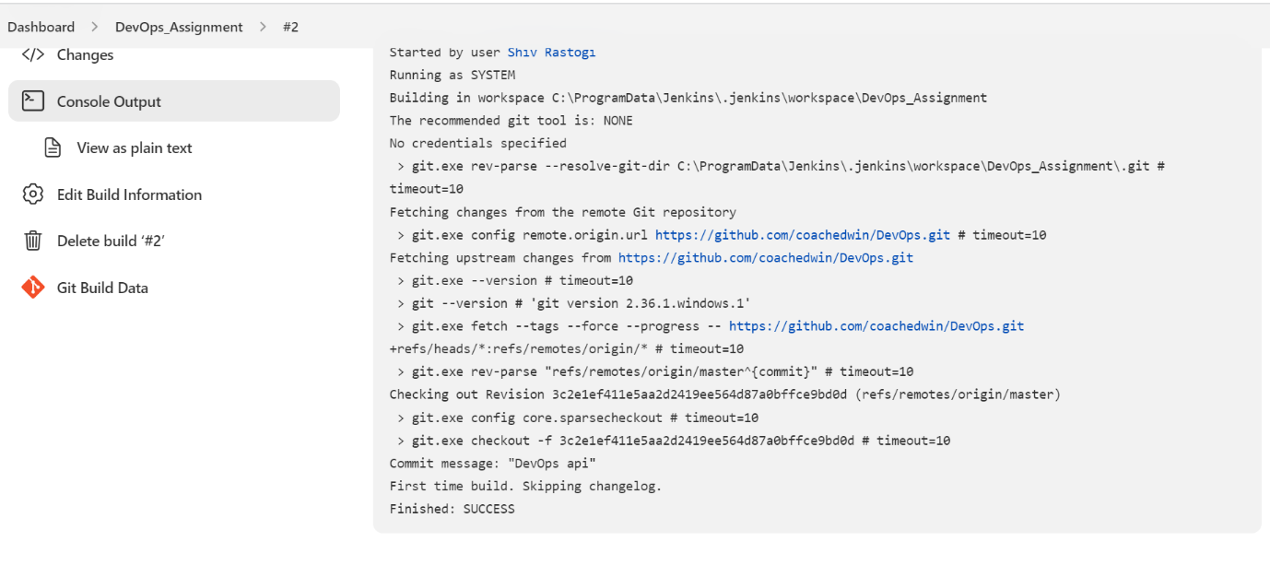

2. Create pipeline to build and test basic springboot application

1. Create freestyle Jenkins pipeline to build and deploy a spring boot API/Web App using Docker

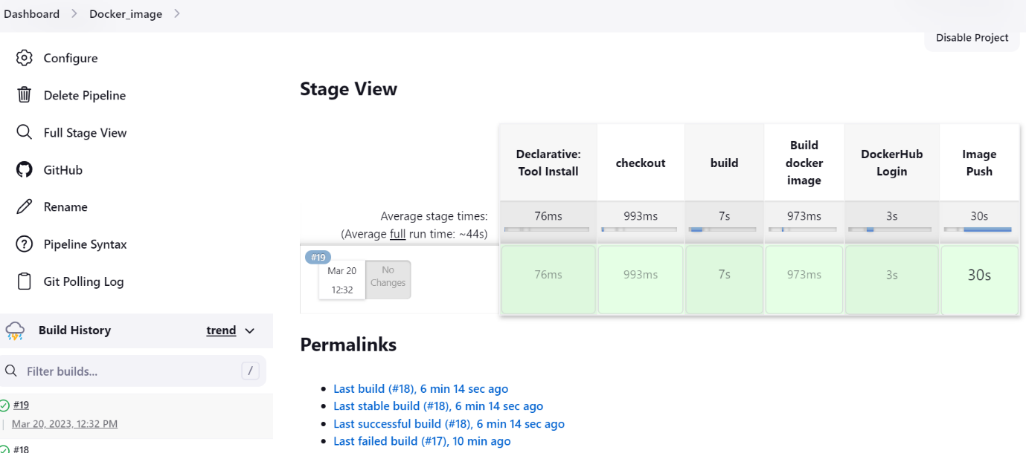

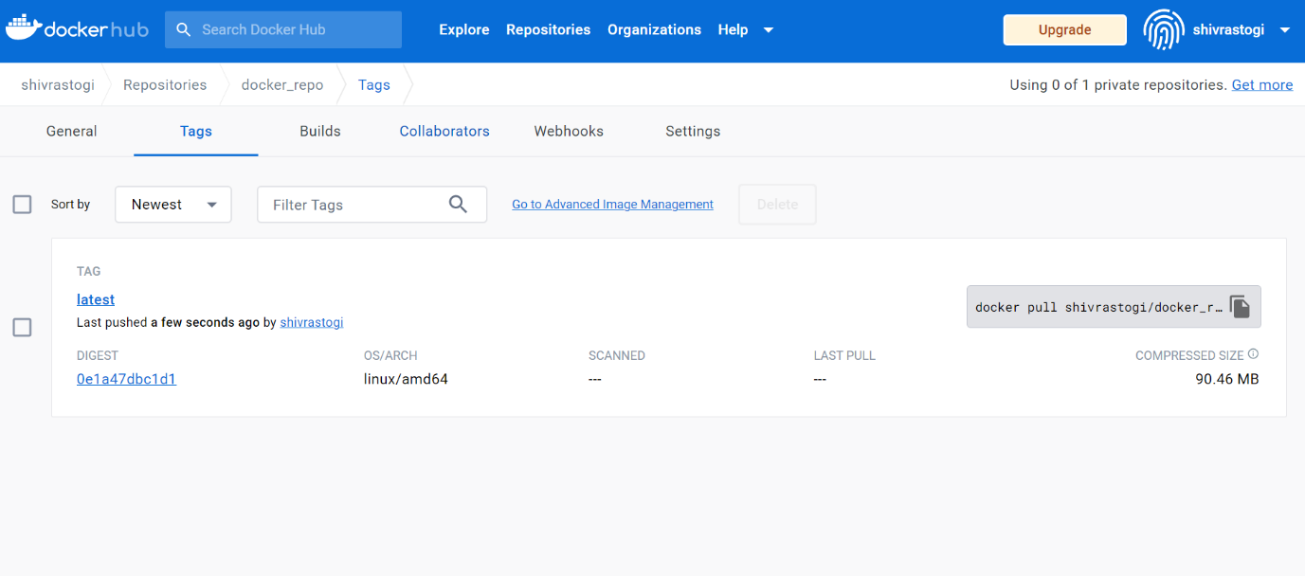

1. Extend pipeline to integrate SonarQube (Bonus)

